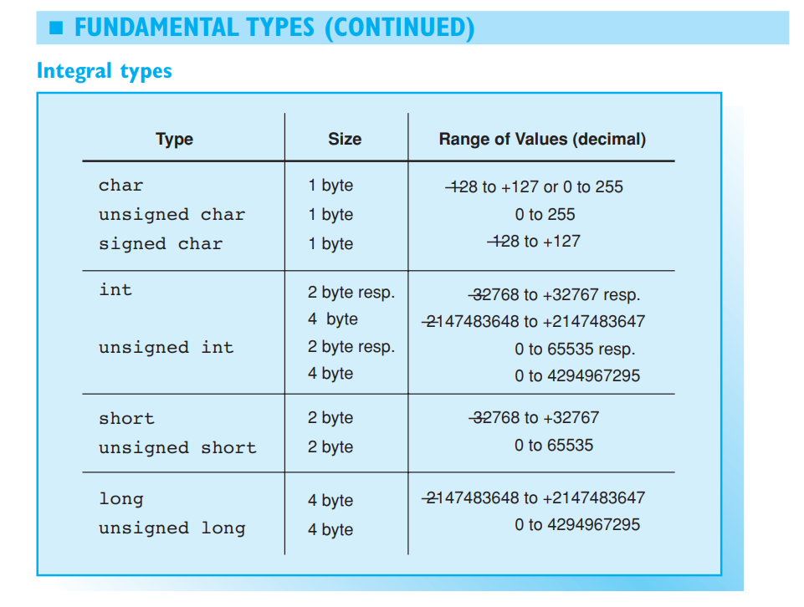

#include <iostream>

#include <climits> // Definition of INT_MIN, ...

using namespace std;

int main()

{

cout << "Range of types int and unsigned int"

<< endl << endl;

cout << "Type Minimum Maximum"

<< endl

<< "--------------------------------------------"

<< endl;

cout << "int " << INT_MIN << " "

<< INT_MAX << endl;

cout << "unsigned int " << " 0 "

<< UINT_MAX << endl;

return 0;

}

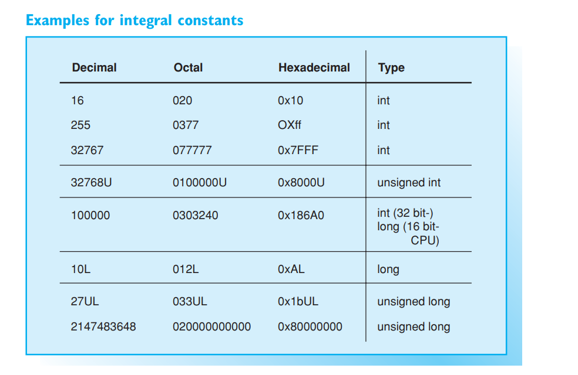

// To display hexadecimal integer literals and

// decimal integer literals.

//

#include <iostream>

using namespace std;

int main()

{

// cout outputs integers as decimal integers:

cout << "Value of 0xFF = " << 0xFF << " decimal"

<< endl; // Output: 255 decimal

// The manipulator hex changes output to hexadecimal

// format (dec changes to decimal format):

cout << "Value of 27 = " << hex << 27 <<" hexadecimal"

<< endl; // Output: 1b hexadecimal

return 0;

}

